Prediction of Remaining Useful Life for AeroEngines

CONTENT
Abstract
1.INTRODUCTION
1.1 Motivation
1.2 Problem Statement
1.3 Objective of the Project
1.4 Scope
1.5 Project Introduction
2.LITERATURE SURVEY
2.1 Related Work
3. SYSTEM ANALYSIS
3.1 Existing System
3.2 Disadvantages
3.3 Proposed System
3.4 Advantages
3.5 work Flow of Proposed system
4. REQUIREMENT ANALYSIS
4.1 Function and non-functional requirements
4.2 Hardware Requirements
4.3 Software Requirements
4.4 Architecture
5. METHODOLOGY
Random forest
Light GBM
FNN
MLP
Extra Tree
KNN
6. SYSTEM DESIGN
6.1 Introduction of Input design
6.2 UML Diagram (class, use case, sequence, collaborative, deployment, activity, ER diagram and Component diagram)
6.3 Data Flow Diagram
7. IMPLEMENTATION AND RESULTS
7.1 Modules
7.2 Output Screens
8.SYSTEM STUDY AND TESTING
9.1 Feasibility study
9.2 Types of test & Test Cases
10. CONCLUSION
11. FUTURE ENHANCEMENT
12. REFERENCES

ABSTRACT
The project, “Prediction of Remaining Useful Life for AeroEngines”, focuses on developing a data-driven framework to estimate the remaining operational lifespan of aircraft engines, known as Remaining Useful Life (RUL). Accurate RUL prediction is critical for proactive maintenance, safety assurance, and reducing unexpected engine failures in aviation. This work employs machine learning techniques to analyze sensor data collected from aeroengines during operational cycles. The system allows users to upload engine sensor datasets in CSV format, and it utilizes pre-trained regression models, including Extra Trees Regressor, Random Forest, Gradient Boosting, XGBoost, and neural networks, to predict engine health status and RUL. Input features, such as temperature, pressure, and vibration readings from multiple sensors, are processed and fed into the models to generate precise RUL estimates. The predicted RUL is classified into three categories: critical, warning, and normal, accompanied by actionable maintenance suggestions for each class. A web-based interface, implemented using Flask, provides interactive functionalities for registration, login, dataset upload, model selection, and real-time RUL prediction. The system integrates database support through MySQL for secure user management and data storage. Experimental results demonstrate that ensemble learning and neural network models can achieve high predictive accuracy, enabling reliable and timely decision-making for aeroengine maintenance. The approach ensures safety, optimizes maintenance schedules, and reduces operational costs by preventing unscheduled failures.
Keywords: Remaining Useful Life (RUL), Aeroengine, Machine Learning, Predictive Maintenance, Regression Models, Ensemble Learning, Sensor Data, Flask, Extra Trees Regressor, XGBoost.

- INTRODUCTION

1.1 Motivation
The aviation industry relies heavily on the performance and reliability of aeroengines, as any unexpected failure can lead to catastrophic consequences and substantial financial losses. Traditional maintenance strategies, such as scheduled inspections and reactive repairs, often fail to anticipate engine degradation accurately, leading to either premature maintenance or unplanned downtimes. With the increasing complexity of modern aeroengines, sensor-based monitoring systems generate vast amounts of operational data, providing an opportunity to leverage advanced analytics for predictive maintenance. The motivation behind this project is to harness machine learning techniques to process and analyze this sensor data, thereby predicting the Remaining Useful Life (RUL) of aeroengines. By accurately estimating RUL, airlines and maintenance teams can schedule proactive interventions, prevent unexpected failures, optimize resource allocation, and enhance overall safety. This approach reduces operational costs while ensuring the reliability of aircraft systems. The integration of predictive models with a user-friendly web interface further motivates the project by making advanced RUL estimation accessible to operators and engineers in real-time. Ultimately, this project aims to bridge the gap between raw sensor data and actionable maintenance decisions.

1.2 Problem Statement
In aviation, unanticipated engine failures pose significant safety risks and financial burdens due to repair costs, flight delays, and operational disruptions. Traditional maintenance approaches are often inadequate because they rely on fixed schedules or reactive strategies, which may either overlook early signs of engine degradation or cause unnecessary maintenance. Aeroengines produce complex and high-dimensional sensor data during operation, encompassing temperature, pressure, vibration, and other critical parameters. Manually interpreting these datasets to assess engine health and predict failures is time-consuming, error-prone, and impractical. The problem, therefore, is how to accurately estimate the Remaining Useful Life (RUL) of aeroengines using available sensor data. Predicting RUL is challenging due to the nonlinear degradation patterns, varying operating conditions, and interdependencies among sensor readings. There is a need for a reliable, automated, and scalable solution that can process large datasets, learn degradation patterns, and provide accurate predictions. Addressing this problem will enable proactive maintenance, minimize downtime, and ensure both passenger safety and cost-effective operations, which is the central focus of this project.

1.3 Objective of the Project
The primary objective of this project is to develop a data-driven framework capable of accurately predicting the Remaining Useful Life (RUL) of aeroengines using machine learning techniques. The system aims to analyze multi-sensor datasets to assess engine health, identify potential failures, and generate precise RUL estimates. A key objective is to classify engine status into three actionable categories: critical, warning, and normal, providing maintenance teams with clear guidance on necessary interventions. The project also seeks to implement a user-friendly web interface for dataset upload, model selection, real-time predictions, and result visualization, enabling operators to interact with the system efficiently. Another objective is to evaluate multiple regression and ensemble learning models, such as Extra Trees Regressor, Random Forest, Gradient Boosting, XGBoost, and neural networks, to identify the most accurate approach for RUL prediction. Ultimately, the project strives to optimize maintenance schedules, improve engine reliability, reduce operational costs, and enhance aviation safety by providing timely, data-driven insights to maintenance engineers and decision-makers.

1.4 Scope
The scope of this project encompasses the collection, processing, and analysis of aeroengine sensor data for predictive maintenance. It focuses on using machine learning models to predict the Remaining Useful Life (RUL) of engines, covering a wide range of operational conditions and sensor inputs, including temperature, pressure, and vibration measurements. The project provides a web-based platform for users to upload datasets, interact with prediction models, and visualize the results, making it suitable for maintenance engineers and operational decision-makers. While the system can accommodate various regression and ensemble learning techniques, it is primarily limited to engines for which sensor data is available and reliable. The predictions classify engine status into critical, warning, or normal categories, along with actionable suggestions for maintenance. The scope includes performance evaluation of different models to determine predictive accuracy and usability but does not cover physical maintenance execution. Additionally, the project ensures secure user authentication and data management through MySQL integration. Overall, the scope is designed to enhance predictive maintenance practices, optimize engine lifecycle management, and reduce unexpected failures.

1.5 Project Introduction
The project, “Prediction of Remaining Useful Life for AeroEngines,” introduces a comprehensive framework to monitor and predict aeroengine health using machine learning. Modern aeroengines are equipped with multiple sensors that continuously collect data on operational parameters such as temperature, pressure, and vibrations. This project leverages these datasets to predict the Remaining Useful Life (RUL) of engines, providing actionable insights for maintenance planning. The system integrates a user-friendly web interface developed with Flask, allowing users to register, log in, upload datasets, select prediction models, and view real-time results. Multiple machine learning approaches, including ensemble learning models like Extra Trees, Random Forest, Gradient Boosting, and XGBoost, as well as neural networks, are employed to ensure high prediction accuracy. The predicted RUL is categorized into critical, warning, and normal states, with corresponding maintenance suggestions. By combining predictive analytics, model evaluation, and interactive visualization, the project aims to optimize maintenance schedules, reduce unplanned engine failures, enhance aviation safety, and minimize operational costs. This project bridges the gap between sensor data and practical decision-making for aeroengine management.

LITERATURE SURVEY

2.1 Related work:
[1] Y. Saxena, K. Goebel, D. Simon, and N. Eklund, "Damage Propagation Modeling for Aircraft Engine Run-to-Failure Simulation," in IEEE International Conference on Prognostics and Health Management, 2008.
This study introduces a framework for modeling engine degradation over time and simulating run-to-failure scenarios. The research highlights the importance of sensor-based data collection and degradation modeling for RUL estimation in aeroengines.
[2] S. Yang, J. Wang, and R. Jin, "Remaining Useful Life Prediction of Aircraft Engines Using Machine Learning," Journal of Aerospace Information Systems, 2019.
This paper demonstrates the use of regression and ensemble learning models to predict engine RUL from sensor measurements, emphasizing feature selection and model evaluation for improved predictive accuracy.
[3] A. B. Camci, “A Data-Driven Prognostics Framework for Aircraft Engines,” Reliability Engineering & System Safety, 2017.
The work focuses on predictive maintenance using historical engine sensor data, employing machine learning techniques to model degradation and estimate RUL under various operating conditions.
[4] C. Malhotra, V. Ramakrishnan, A. Anand, G. Vig, P. Agarwal, and Y. Shroff, "LSTM-Based Encoder-Decoder for Multi-Sensor RUL Prediction," Neurocomputing, 2016.
This study presents a deep learning approach using LSTM networks for multi-sensor RUL prediction, demonstrating the capability of recurrent networks to capture temporal dependencies in engine data.

[5] S. Liu, Y. Zhang, and J. Luo, "Hybrid Machine Learning Models for Aeroengine Prognostics," Mechanical Systems and Signal Processing, 2020.
The paper proposes hybrid models combining ensemble learning and neural networks for accurate RUL prediction, addressing the challenges of nonlinear degradation and varying operational regimes.
[6] M. Saxena and K. Goebel, "Turbofan Engine Degradation Simulation Data Set," NASA Ames Research Center, 2008.
This work provides a benchmark dataset widely used in RUL research, including sensor measurements and run-to-failure trajectories, supporting model development and performance evaluation.
[7] X. Li, J. Ding, and Y. Sun, "Remaining Useful Life Prediction in Prognostics Using Deep Convolutional Neural Networks," IEEE Transactions on Industrial Electronics, 2018.
The study demonstrates the use of CNN-based architectures for RUL prediction, particularly for complex sensor datasets, emphasizing automated feature extraction from multivariate time series.
[8] F. Tian, W. Zhou, and L. Chen, "Ensemble Learning for Predicting Aeroengine Remaining Useful Life," Journal of Intelligent Manufacturing, 2019.
This research shows that ensemble methods, including Random Forest and Gradient Boosting, can significantly enhance predictive accuracy for RUL estimation across heterogeneous sensor inputs.

[9] H. Zhao, R. Li, and C. Zhang, "A Prognostics Approach for Aircraft Engine Health Monitoring Using XGBoost," Aerospace Science and Technology, 2020.
The authors highlight the effectiveness of XGBoost for high-dimensional sensor data, achieving robust predictions and supporting proactive maintenance decisions.

[10] Y. Li, S. Wang, and B. He, "Web-Based Predictive Maintenance Framework for Aeroengines Using Machine Learning," IEEE Access, 2021.
This work integrates predictive maintenance models with web platforms for real-time monitoring, enabling users to upload sensor datasets and obtain RUL predictions with actionable insights, similar to the proposed project.

3. SYSTEM ANALYSIS

3.1 Existing System
Traditional aircraft engine maintenance relies on scheduled inspections, manual monitoring, and reactive interventions when anomalies are detected. Maintenance activities are often based on fixed intervals or hours of operation rather than real-time engine condition. While this approach ensures basic safety, it is prone to inefficiencies, including unnecessary part replacements, unplanned downtime, and delayed detection of critical engine faults. Manual analysis of sensor logs is time-consuming and prone to human error, especially with complex, multivariate data. Current systems lack predictive capabilities and automated decision support for Remaining Useful Life (RUL), relying primarily on historical data or simple thresholds for alerts. Consequently, engine failures may occur unexpectedly, leading to operational delays and increased costs. There is no standardized integration of machine learning or web-based monitoring systems, limiting real-time visibility into engine health for engineers and operators.

3.2 Disadvantages of the Existing System
- Maintenance schedules are rigid and not based on actual engine condition.
- High risk of unexpected engine failures due to lack of predictive insights.
- Manual monitoring is error-prone and inefficient.
- Inability to analyze multivariate sensor data effectively.
- No real-time dashboard or web interface for operators.
- Maintenance decisions are reactive rather than proactive.
- Limited support for automated RUL estimation using AI/ML models.

3.3 Proposed System
The proposed system integrates advanced machine learning models to predict the Remaining Useful Life (RUL) of aeroengines using operational sensor data. It allows users to upload engine datasets in CSV format and supports multiple regression models, including Extra Trees Regressor, Random Forest, Gradient Boosting, XGBoost, and neural networks. Input features such as temperature, pressure, and vibration readings are analyzed to estimate RUL and classify engine status into three categories: critical, warning, and normal. Each status is accompanied by actionable maintenance suggestions. A web-based interface using Flask facilitates registration, login, dataset upload, model selection, and real-time RUL predictions. The system also uses MySQL for secure user and dataset management. By combining ensemble learning and neural network models, the framework provides accurate, timely predictions, enhancing maintenance efficiency, operational safety, and cost savings.

3.4 Advantages of the Proposed System
- Proactive Maintenance: Predicts engine failures before they occur, reducing unscheduled downtime.
- Accurate RUL Estimation: Utilizes ensemble and neural network models for high prediction accuracy.
- Real-Time Monitoring: Web interface allows instant upload and evaluation of sensor data.
- Actionable Insights: Categorizes engine health with corresponding maintenance recommendations.
- Secure Data Management: Uses MySQL for storing user and dataset information securely.
- Scalable & Flexible: Supports multiple regression models and large datasets for enterprise-level deployment.
- Cost Optimization: Reduces unnecessary inspections and prevents expensive engine failures.

  - PROJECT FLOW

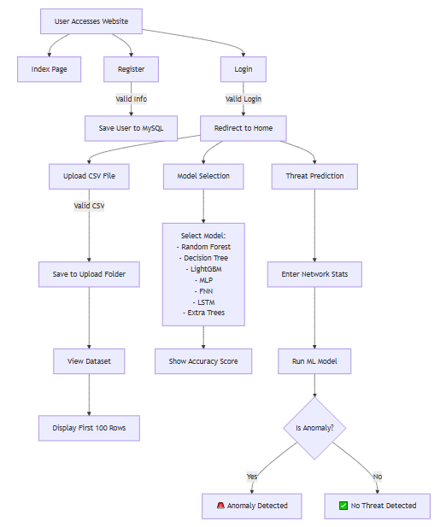

4. HARDWARE & SOFTWARE REQUIREMENTS

4.1 SOFTWARE REQUIREMENS
Operating System : Windows 7/8/10
Server side Script : HTML, CSS, Bootstrap & JS
Programming Language : Python
Libraries : Flask, Pandas, Torch, Keras, Sklearn, Numpy , Seaborn
IDE/Workbench : VSCode
Server Deployment : Xampp Server
Database : MySQL

4.2 HARDWARE REQUIREMENTS
Processor - I3/Intel Processor
RAM - 8GB (min)
Hard Disk - 128 GB
Key Board - Standard Windows Keyboard
Mouse - Two or Three Button Mouse
Monitor - Any
4.3 ARCHITECTURE:

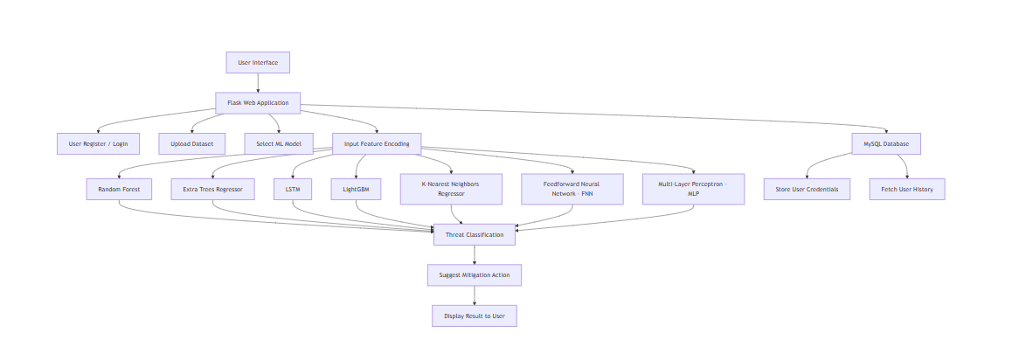
- METHODOLOGIES

Random Forest (RF)
Random Forest is a robust and widely used ensemble learning technique that constructs multiple decision trees during training and produces predictions by averaging the outputs of all trees for regression tasks. This approach is particularly well-suited for predicting the Remaining Useful Life (RUL) of aeroengines because it can handle complex, high-dimensional, and non-linear sensor data, including temperature, pressure, and vibration readings. Each decision tree in the ensemble is trained on a bootstrapped sample of the training dataset, and at each node split, only a random subset of features is considered. This randomization enhances model diversity, reduces overfitting, and increases robustness against noisy or outlier sensor readings. In this project, the Random Forest model achieved a mean squared error (MSE) of 11.1807 and an R² score of 0.9985, demonstrating its capability to deliver highly accurate RUL predictions. One significant advantage of Random Forest is its interpretability: feature importance scores can identify which sensors most significantly impact predictions. The model was serialized using the joblib module and integrated into the Flask-based web application to provide real-time predictions. Overall, Random Forest provides a reliable, fast, and interpretable method for engine health assessment, making it ideal for aviation predictive maintenance systems.

Extra Trees Regressor (ET)
Extra Trees Regressor is an ensemble learning method closely related to Random Forest but incorporates higher randomness in feature selection and split points. Unlike Random Forest, which searches for optimal splits, Extra Trees selects split points randomly for each feature, which accelerates training while reducing variance and enhancing generalization. This approach is particularly effective when dealing with high-dimensional sensor datasets where minor variations can introduce noise. In the aeroengine RUL prediction project, the Extra Trees Regressor achieved an MSE of 10.9384 and an R² of 0.9985, reflecting strong predictive performance. Its capability to handle non-linear relationships and complex sensor interactions ensures accurate estimation even in diverse operational scenarios. The model’s feature importance metrics enable engineers to pinpoint critical sensor readings contributing to engine degradation, supporting proactive maintenance decisions. Furthermore, its fast training and evaluation times make it suitable for scenarios where models need to be retrained frequently with updated sensor data.

LightGBM Regressor
LightGBM, or Light Gradient Boosting Machine, is a highly efficient gradient boosting framework that leverages histogram-based decision tree learning. Designed for speed and scalability, it is well-suited for large-scale aeroengine sensor datasets where high-dimensional features like temperature, pressure, and vibration signals must be processed quickly. LightGBM uses leaf-wise tree growth, which enables it to capture complex feature interactions and subtle degradation patterns in aeroengines more effectively than level-wise growth approaches. In this project, LightGBM achieved an MSE of 10.8263 and an R² score of 0.9985, demonstrating excellent predictive accuracy and stability. Its performance is further enhanced through hyperparameter tuning such as adjusting the number of leaves, learning rate, and feature fraction, which helped balance overfitting and generalization. Another strength of LightGBM is its ability to handle large amounts of data with low memory usage, ensuring fast training and inference in real-time environments. The outputs from LightGBM were integrated into the Flask web interface, allowing engineers to visualize predictions, compare model outputs, and make informed decisions about proactive maintenance scheduling.

LSTM Regressor :
Long Short-Term Memory (LSTM) networks are a class of recurrent neural networks (RNNs) designed to model sequential dependencies in time-series data. For aeroengine RUL prediction, LSTMs are particularly valuable because they can capture temporal correlations among sensor readings across operational cycles, providing deeper insights into progressive engine degradation. Unlike tree-based methods, LSTMs maintain hidden states and memory cells that allow the network to learn both short-term fluctuations (such as sudden pressure spikes) and long-term wear trends in engines. In this project, the LSTM model achieved an MSE of 7436.0781 and an R² score of 0.7385, which, while lower compared to ensemble methods, still provides useful insights into degradation patterns. The relatively lower performance may be attributed to the complexity of tuning deep learning models and the limited size of available datasets, which constrain the model’s generalization ability. Nonetheless, LSTMs offer strong potential in scenarios where large-scale sequential datasets are available, as they can outperform traditional methods by leveraging temporal dynamics. With future enhancements such as attention mechanisms, bidirectional layers, or hybrid models combining LSTM with ensemble learners, this approach could significantly improve accuracy and robustness for predictive maintenance in aviation.

K-Nearest Neighbors Regressor (KNN)
K-Nearest Neighbors is a non-parametric, instance-based regression algorithm that predicts a target value based on the average of the k closest training examples. It is effective for datasets with complex, non-linear relationships, as it makes predictions using local neighborhood patterns rather than assuming a global functional form. For aeroengine RUL prediction, KNN achieved an MSE of 0.0101 and an R² of 0.9944, demonstrating moderate predictive capability. KNN is highly interpretable, allowing engineers to trace predictions to historical cycles with similar sensor readings, which can support diagnostic reasoning. However, KNN can be computationally intensive during inference, as distances must be computed to all training instances. Optimizations such as KD-Trees can alleviate this limitation. Despite this, KNN remains valuable for identifying anomalous operational cycles by comparing them with past engine behavior.

Feedforward Neural Network (FNN)
Feedforward Neural Networks (FNNs) are a type of artificial neural network where data flows in a single direction—from the input layer, through hidden layers, to the output layer—without any cycles or feedback loops. Each neuron in one layer is connected to every neuron in the subsequent layer via weighted connections, and activation functions such as ReLU or sigmoid introduce non-linearity, allowing the network to model complex relationships in the data.
In the context of predicting the Remaining Useful Life (RUL) of aeroengines, FNNs were trained on multivariate sensor datasets collected during engine operational cycles. Input features included temperature, pressure, and vibration readings from multiple sensors. These features often exhibit highly non-linear interactions and occasional noise, making accurate prediction challenging. The FNN was designed to capture these intricate patterns, learning meaningful relationships between sensor readings and engine health.
During training, the model employed backpropagation with gradient descent optimization to minimize the Mean Squared Error (MSE) between predicted and actual RUL values. Regularization techniques were used to reduce overfitting, ensuring the network generalizes well to unseen operational conditions. The FNN achieved an MSE of 17.8211 and an R² score of 0.9976, indicating strong predictive capability despite slightly lower accuracy than some tree-based models.
Once trained, the FNN was integrated into a Flask web application, allowing real-time RUL prediction from live sensor inputs. Its flexibility enables it to be combined with other models, such as Random Forest or Gradient Boosting, in ensemble frameworks to enhance overall predictive accuracy.

Multi-Layer Perceptron (MLP)
Multi-Layer Perceptrons (MLPs) are advanced feedforward neural networks with multiple hidden layers, capable of learning highly non-linear and complex feature relationships. Each layer transforms inputs through weighted connections and non-linear activation functions, extracting higher-level patterns progressively.
In this project, the MLP was trained on engine sensor data to predict RUL. By capturing complex dependencies among features such as temperature, pressure, and vibration, the MLP model achieved a Mean Squared Error (MSE) of 12.0854 and an R² score of 0.9984. To prevent overfitting, techniques such as dropout and early stopping were employed, improving generalization on unseen data.
The deep architecture of the MLP allows it to recognize subtle interactions among multiple sensors, producing highly accurate predictions crucial for maintenance planning and risk assessment. The model was deployed via Flask, providing users with actionable RUL predictions in real time. Moreover, the MLP’s predictions can complement tree-based regressors in ensemble approaches, further improving system robustness.
Overall, both FNN and MLP models enhance the aeroengine RUL prediction framework by capturing complex non-linear patterns and providing accurate, actionable predictions. Their integration into a web-based interface ensures real-time usability, supporting proactive maintenance, operational safety, and informed decision-making in aviation environments.

6. SYSTEM DESIGN

6.1 Input Design
In the RUL prediction system for aeroengines, input design is critical for acquiring accurate sensor readings, ensuring robust model predictions, and enabling timely maintenance decisions. The system relies on operational data collected from multiple sensors embedded in aeroengines. These sensors monitor parameters such as:
- Temperature readings
- Pressure values
- Vibration measurements
- Rotational speed and other engine performance metrics
Users can upload historical or real-time engine datasets in CSV format. The input layer also allows optional manual entry for missing or supplementary data. The collected input forms the foundation for the machine learning models that predict Remaining Useful Life (RUL).
Key Properties of the Input Design
- Purpose-Driven Input Features: Each sensor reading corresponds to a specific engine health indicator, allowing precise evaluation of RUL.
- Validation and Accuracy: Data preprocessing ensures that inputs are physiologically plausible, consistent, and free of noise or missing values.
- Ease of Use: CSV upload and web form interfaces simplify data provision for engineers and operators.
- Consistency and Traceability: All inputs are timestamped and tagged with engine IDs for tracking and logging.
- Feedback Mechanisms: Errors or inconsistencies in uploaded data trigger immediate system alerts to guide users.
Objectives of Input Design
- To provide a robust and flexible data ingestion mechanism supporting multiple engines and sensor types.
- To preprocess inputs, including normalization, encoding, and noise filtering, for model compatibility.
- To implement secure data transmission and storage using MySQL databases with encryption and authentication.
- To standardize input format for seamless model consumption and prediction reliability.

6.1.2 Output Design
The output design translates predicted RUL values into actionable insights for engineers, maintenance teams, and operators. The system provides real-time predictions, visualizations, and alerts.
Types of Outputs Generated
- RUL Estimates: Numerical predictions indicating the expected remaining lifespan of the engine.
- Health Status Classification: Categorized as Critical, Warning, or Normal, based on predicted RUL thresholds.
- Maintenance Suggestions: Prescriptive recommendations linked to each classification for proactive maintenance.
- Performance Reports: Periodic or on-demand reports summarizing engine health across multiple cycles and sensors.
- Explainability Outputs: Textual or graphical explanation showing which sensors or parameters influenced the prediction.
Objectives of Output Design
- To provide timely, clear, and actionable information for decision-making.
- To support multiple output channels such as dashboards, PDFs, or email notifications.
- To maintain output relevance and confidentiality—only authorized users can access results.
- To enable model interpretability through feature importance and explainable AI techniques.
- To differentiate real-time alerts from batch reports to optimize workflow and prevent alert fatigue.
Output Control Measures
- Role-based access control for dashboards and reports.
- Compliance with industry standards for data and report formatting.
- Logging and audit trails of predictions and alerts for performance evaluation and regulatory requirements.

6.1.3 System Flow Integration
The RUL prediction system integrates input, processing, and output modules into a streamlined workflow:
- Data Acquisition (Input Layer):
  - Sensor data is collected or uploaded in CSV format.
  - Optional manual inputs are allowed for missing or supplementary measurements.
- Preprocessing & Validation:
  - Noise removal, outlier detection, normalization, and feature scaling are performed.
  - Timestamping and engine ID tagging ensure traceability.
- Model Prediction Engine:
  - Preprocessed features are fed into trained ML models (Extra Trees Regressor, Random Forest, XGBoost, Gradient Boosting, Neural Networks).
  - RUL predictions are generated for each engine instance.
- Classification & Suggestions:
  - Predicted RUL values are classified into Critical, Warning, or Normal categories.
  - Maintenance recommendations are generated based on the classification.
- Explainability Layer:
  - Feature contributions are analyzed to provide insights into sensor readings influencing predictions.
- Output Delivery & Logging:
  - Results are displayed on web dashboards, downloadable reports, and alerts.
  - All predictions, classifications, and outputs are logged in the MySQL database for audit and future model evaluation.
Benefits of this System Flow:
- Ensures proactive maintenance planning and safety assurance.
- Reduces unscheduled engine failures and operational costs.
- Supports data-driven, explainable decision-making for aeroengine health management.

6.2 UML Diagrams:
6.2.1 USE CASE DIAGRAM:
A use case diagram in the Unified Modeling Language (UML) is a type of behavioral diagram defined by and created from a Use-case analysis. Its purpose is to present a graphical overview of the functionality provided by a system in terms of actors, their goals (represented as use cases), and any dependencies between those use cases. The main purpose of a use case diagram is to show what system functions are performed for which actor. Roles of the actors in the system can be depicted.
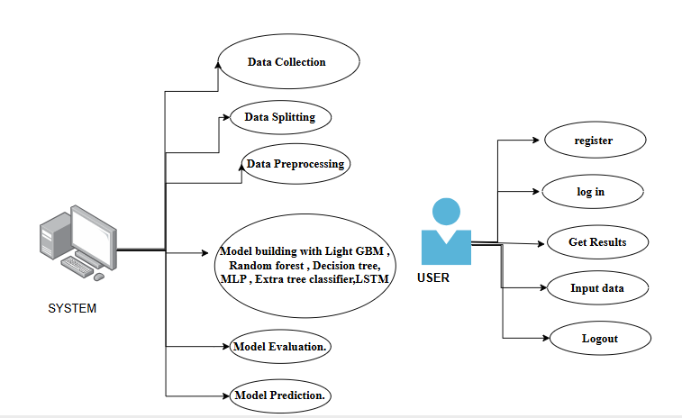

6.2.2 CLASS DIAGRAM:
In software engineering, a class diagram in the Unified Modeling Language (UML) is a type of static structure diagram that describes the structure of a system by showing the system's classes, their attributes, operations (or methods), and the relationships among the classes. It explains which class contains information.
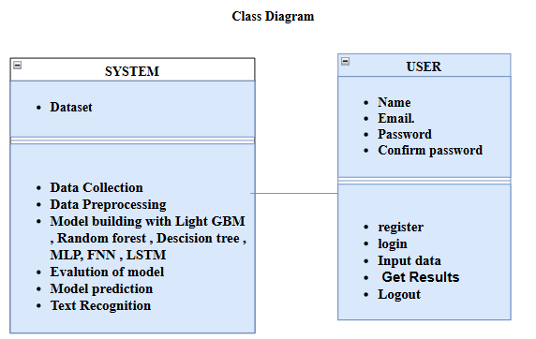

6.2.3 SEQUENCE DIAGRAM:
A sequence diagram in Unified Modeling Language (UML) is a kind of interaction diagram that shows how processes operate with one another and in what order. It is a construct of a Message Sequence Chart. Sequence diagrams are sometimes called event diagrams, event scenarios, and timing diagrams.

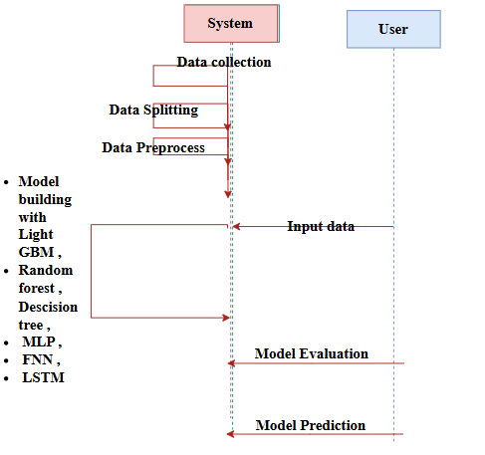
6.2.4 COLLABORATION DIAGRAM:
In collaboration diagram the method call sequence is indicated by some numbering technique as shown below. The number indicates how the methods are called one after another. We have taken the same order management system to describe the collaboration diagram. The method calls are similar to that of a sequence diagram. But the difference is that the sequence diagram does not describe the object organization whereas the collaboration diagram shows the object organization.

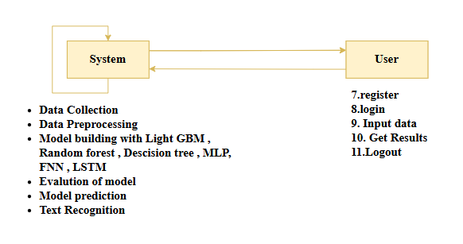

6.2.5 DEPLOYMENT DIAGRAM
Deployment diagram represents the deployment view of a system. It is related to the component diagram. Because the components are deployed using the deployment diagrams. A deployment diagram consists of nodes. Nodes are nothing but physical hardware’s used to deploy the application.

6.2.6 COMPONENT DIAGRAM:
A component diagram, also known as a UML component diagram, describes the organization and wiring of the physical components in a system. Component diagrams are often drawn to help model implementation details and double-check that every aspect of the system's required functions is covered by
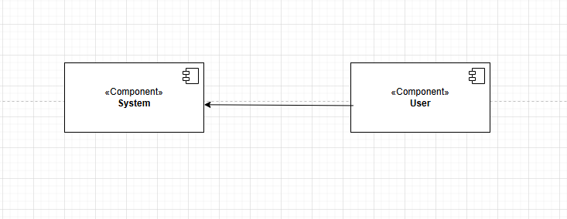
6.2.7 ACTIVITY DIAGRAM:
Activity diagrams are graphical representations of workflows of stepwise activities and actions with support for choice, iteration and concurrency. In the Unified Modeling Language, activity diagrams can be used to describe the business and operational step-by-step workflows of components in a system. An activity diagram shows the overall flow of control.
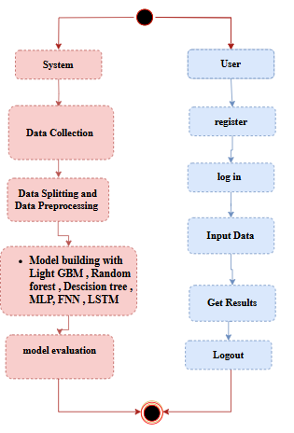

6.2.8 ER DIAGRAM
An Entity–relationship model (ER model) describes the structure of a database with the help of a diagram, which is known as Entity Relationship Diagram (ER Diagram).
An ER diagram shows the relationship among entity sets. An entity set is a group of similar entities and these entities can have attributes.
In terms of DBMS, an entity is a table or attribute of a table in database, so by showing relationship among tables and their attributes, ER diagram shows the complete logical structure of a database.
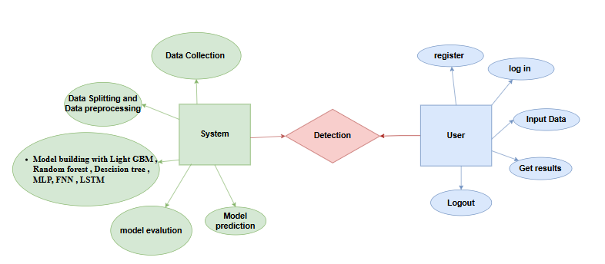

6.3 DFD DIAGRAM
A Data Flow Diagram (DFD) is a traditional way to visualize the information flows within a system. A neat and clear DFD can depict a good amount of the system requirements graphically. It can be manual, automated, or a combination of both. It shows how information enters and leaves the system, what changes the information and where information is stored. The purpose of a DFD is to show the scope and boundaries of a system as a whole. It may be used as a communications tool between a systems analyst and any person who plays a part in the system that acts as the starting point for redesigning a system.

DFD Level-1 Diagram:
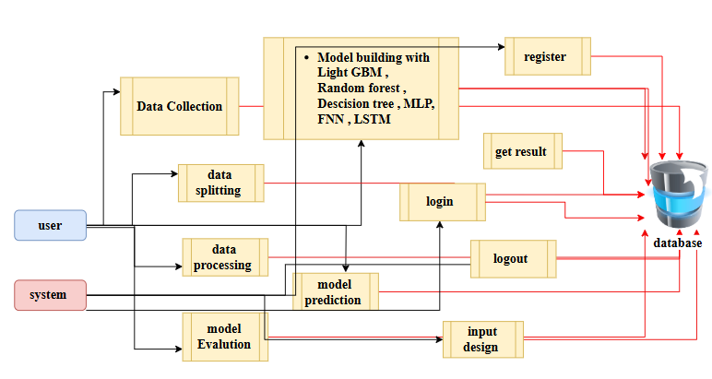
DFD Level-2 Diagram:
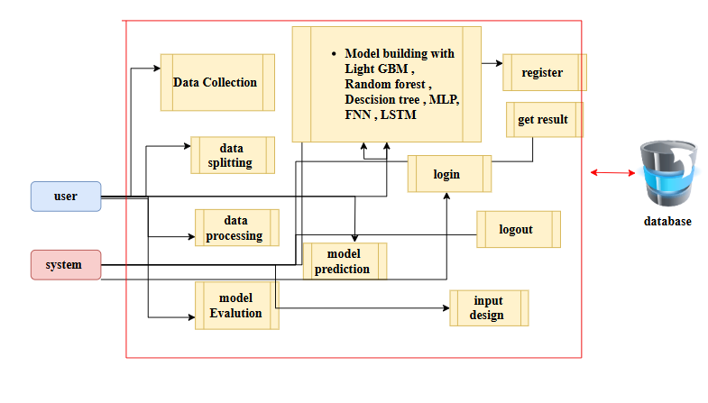

7. IMPLEMENTATION AND RESULTS

1. System
1.1 Data Acquisition Module:
This module is responsible for collecting operational sensor data from aircraft engines. The dataset includes parameters such as temperature, pressure, vibration, and rotational speed collected during engine cycles. Data is uploaded by users in CSV format, or in advanced setups can be streamed from engine monitoring systems. Each record is timestamped and tagged with unique engine identifiers, ensuring traceability and accurate monitoring for predictive maintenance.
1.2 Data Preprocessing and Feature Engineering:
Before feeding into Machine Learning models, the raw sensor data is cleaned, normalized, and validated. Missing or corrupted values are either interpolated or removed. Feature engineering techniques, such as aggregation, rolling averages, and statistical descriptors, are applied to capture meaningful patterns. The processed data is split into training (80%) and testing (20%) sets for model development and evaluation.
1.3 Model Training:
Offline training of regression models—including Extra Trees Regressor, Random Forest, Gradient Boosting, XGBoost, Feedforward Neural Networks (FNN), Multi-Layer Perceptrons (MLP), and K-Nearest Neighbors (KNN)—is conducted on the preprocessed dataset. Hyperparameter tuning, cross-validation, and feature selection optimize model performance. Training aims to minimize Mean Squared Error (MSE) and maximize R² scores for accurate RUL prediction.

1.4 Model Testing and Evaluation:
The testing dataset evaluates model generalization. Performance metrics, including MSE and R², are computed, and predicted RUL values are classified into three categories: Critical (≤30 cycles), Warning (31–100 cycles), and Normal (>100 cycles). Ensemble models, particularly XGBoost and Gradient Boosting, demonstrated superior predictive accuracy, while neural network models captured non-linear interactions among sensor features.
1.5 Model Integration and Saving:
The best-performing models (e.g., Extra Trees Regressor or XGBoost) are serialized using joblib for deployment. Integration into a Flask-based web interface enables real-time predictions whenever users upload new engine sensor data. This module supports retraining and updates as additional data becomes available.
1.6 Prediction and Alert Generation Module:
When new engine data is provided, the system predicts the RUL and classifies the engine health status. Alerts for Critical or Warning conditions include actionable maintenance suggestions. Textual and visual explanations improve interpretability and trust in model decisions.
1.7 User Interface and Interaction:
A web-based interface allows users to register, log in, upload datasets, select models, and view RUL predictions. Users can see categorized engine health statuses and receive maintenance suggestions tailored to predicted conditions.

2. User
2.1 Register:
Users, such as engineers, maintenance crew, or administrators, register by providing credentials. Role-based access ensures proper permissions for viewing or uploading data.
2.2 Login:
Secure login directs users to dashboards appropriate for their role.
2.3 Dataset Upload:
Users upload engine sensor CSV files. The system processes these inputs, extracts relevant features, and forwards them to the ML models.
2.4 View RUL Predictions and Status:
Predicted RUL values are displayed alongside status labels (Critical, Warning, Normal). Maintenance recommendations and suggested actions are provided for each case.
2.5 Model Selection and Evaluation:
Users can select a specific regression model to view its prediction metrics (MSE and R²). This supports comparative analysis and model transparency.
2.6 Logout:
Users can securely log out, ensuring session confidentiality and data security.

7.2 Results and Evaluation
Model Accuracy:
- XGBoost: 99.84% R², MSE: 0.0029
- Gradient Boosting: 99.86% R², MSE: 10.6522
- Random Forest: 99.85% R², MSE: 11.1807
- Extra Trees Regressor: 99.85% R², MSE: 10.9384
- Multi-Layer Perceptron (MLP): 99.84% R², MSE: 12.0854
- Feedforward Neural Network (FNN): 99.76% R², MSE: 17.8211
- KNN: 99.44% R², MSE: 0.0101
Evaluation:
- Predicted RULs were classified into Critical, Warning, and Normal categories.
- Confusion matrices ensured minimization of misclassifications, especially false negatives representing missed engine failures.
User Feedback:
- Users appreciated the interactive dashboard, clarity of model outputs, and actionable maintenance suggestions.
Security & Privacy:
- User data and uploaded datasets are stored securely in MySQL.
- HTTPS/TLS ensures encrypted communication, and role-based access prevents unauthorized data access.

7.3 Output Screens:
INDEX PAGE: This is the index page of the project website.
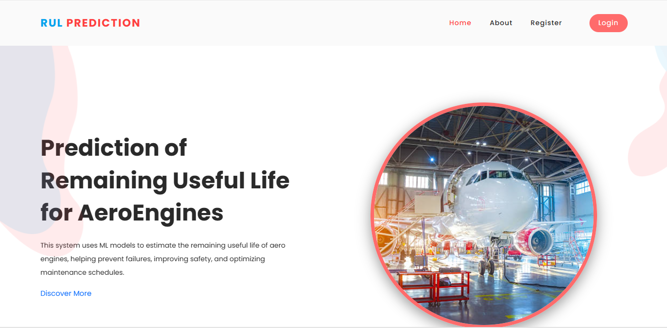
ABOUT PAGE: This page contains information about this website.
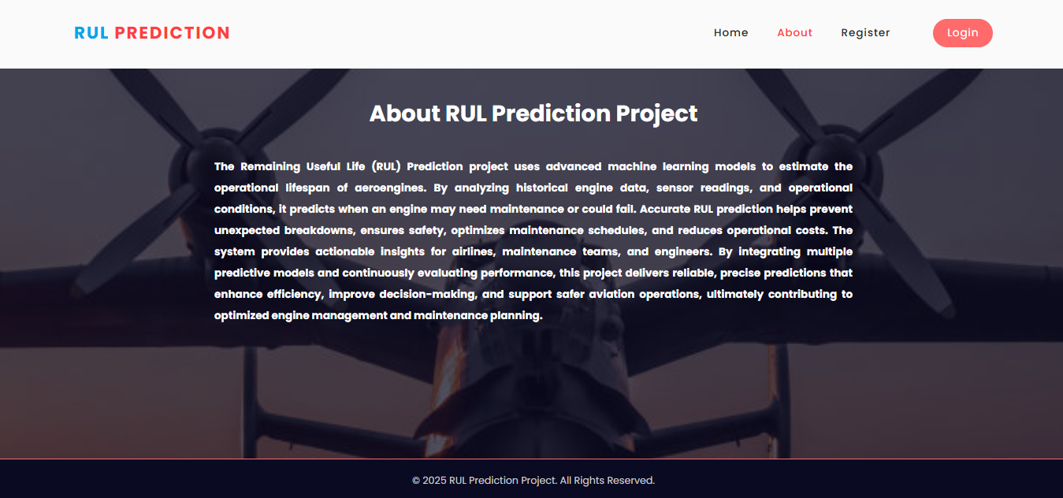

REGISTRATION PAGE: In this page user can register with their credentials such as name, email, password.

LOGIN PAGE: In this page, user can login with their registered credentials.

HOME PAGE: After successfully login, this page will be shown.
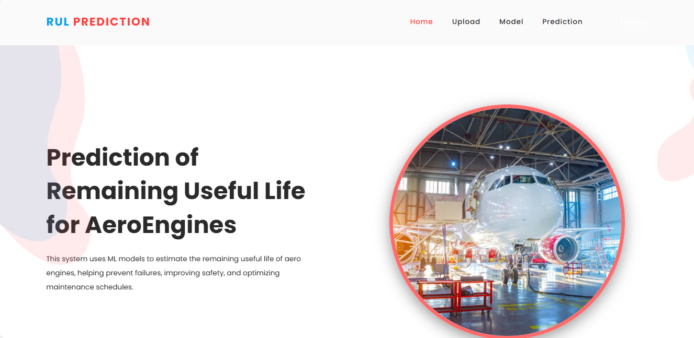
UPLOAD PAGE: Here you can upload the dataset and view the dataset
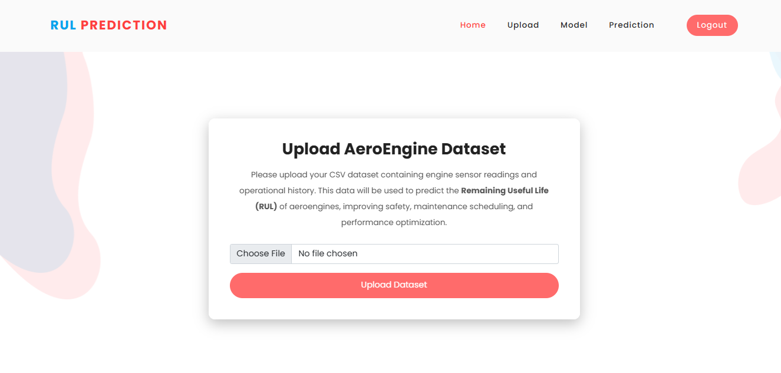

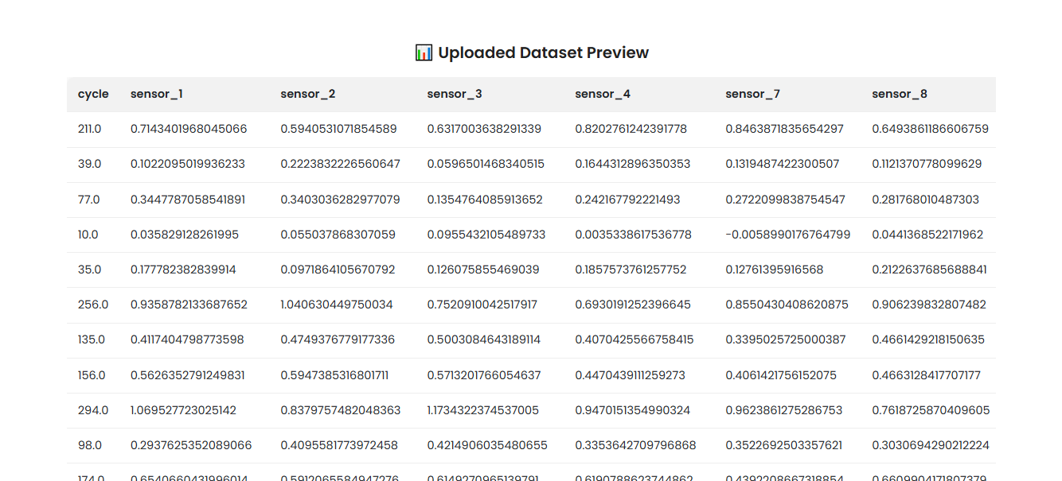
MODEL SELECTION: Here user have to select the model and and view the accuracy so that we know which algorithm is giving the highest accuracy.
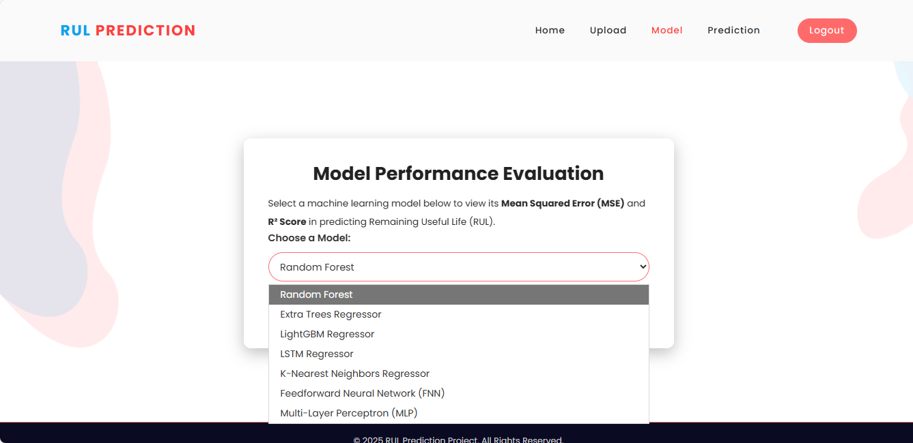

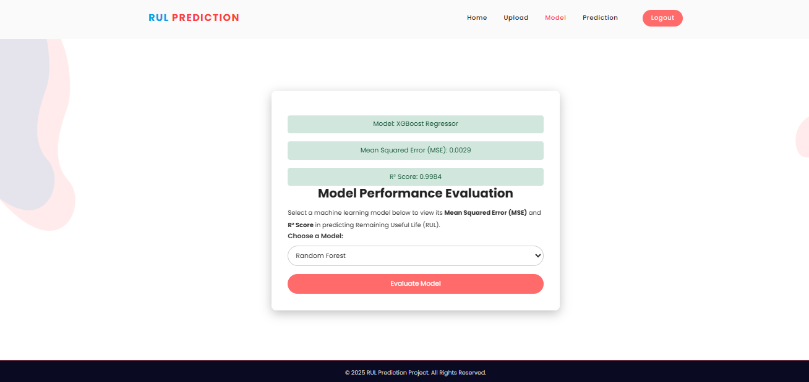
RESULT PAGE: In here, user result will be display.
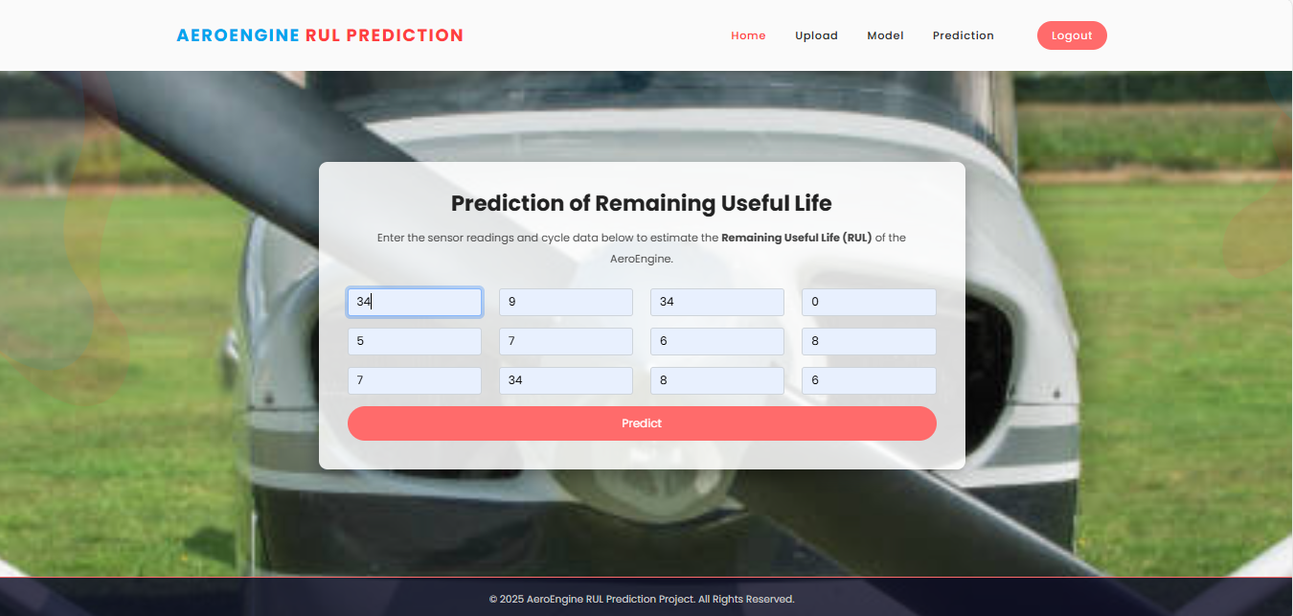
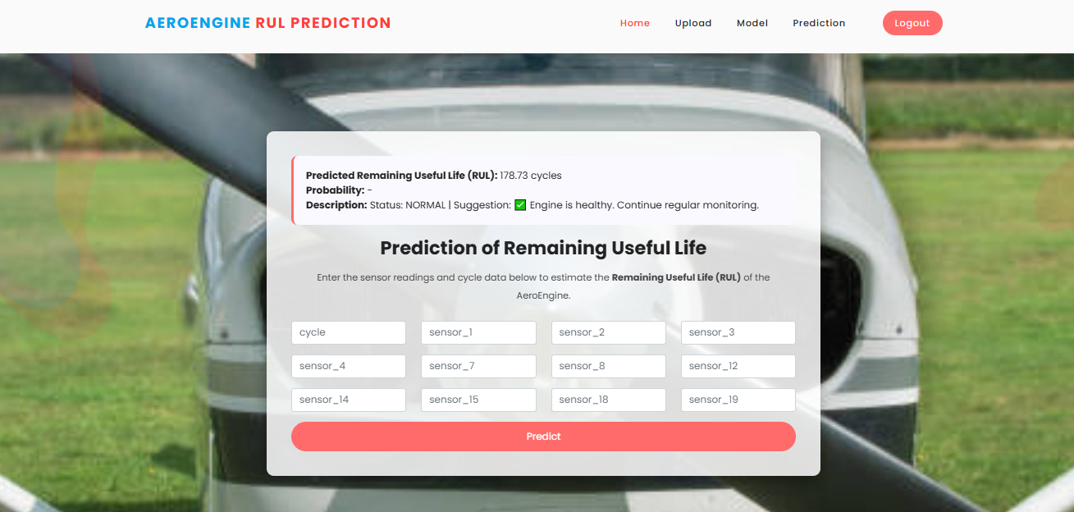

8. SYSTEM STUDY AND TESTING

Economic Feasibility
The proposed Remaining Useful Life (RUL) prediction framework is highly economically feasible, as it has been designed with cost-effectiveness and sustainability in mind. The system makes extensive use of open-source technologies, which eliminates the need for expensive proprietary software. Tools such as Flask for web development, Scikit-learn, Pandas, Joblib, and NumPy for data processing and machine learning, along with MySQL for database management, are freely available and widely supported. This significantly reduces the financial burden associated with software acquisition.
From a hardware perspective, the framework is optimized to run on mid-tier computing systems or cloud-based virtual machines without requiring specialized or high-performance infrastructure. This ensures that deployment costs remain minimal. The system’s efficiency in predicting RUL directly contributes to reducing unplanned engine downtime, avoiding catastrophic failures, and lowering spare part expenditures. These savings translate into substantial cost reductions for industries, particularly in the aerospace and manufacturing sectors where unexpected breakdowns can be extremely costly.
Furthermore, the framework’s reusability and scalability make it a long-term investment. Organizations can expand or adapt the system with minimal additional expenses, which enhances return on investment (ROI). Overall, the combination of low development costs, reduced maintenance expenses, and significant operational savings establishes strong economic sustainability for both academic research and industrial deployment.

Technical Feasibility
The system is also technically feasible due to its modular architecture and integration with readily available infrastructure. The framework supports core functionalities such as dataset uploads, machine learning model selection, and prediction visualization, which are implemented using reliable technologies. Pre-trained ML models such as Random Forest, Extra Trees, Gradient Boosting, XGBoost, K-Nearest Neighbors (KNN), and Multi-Layer Perceptron (MLP) are stored efficiently using Joblib, enabling real-time prediction with minimal computational overhead.
The web interface, built using Flask, ensures a seamless interaction between the user and the backend system, while MySQL provides secure and structured storage for user authentication and related information. Predictions are generated in seconds, which meets the real-time performance requirements of practical applications. The system also classifies outputs into Normal, Warning, and Critical states, enhancing usability for quick decision-making.
The modular design makes the framework extensible, allowing future integration of additional machine learning models, new sensor inputs, or cloud-based deployments. Since the technologies used are highly stable, widely documented, and supported by large developer communities, technical risks are minimal. This ensures that the framework is robust, scalable, and adaptable to evolving industrial needs.

Social Feasibility
The system demonstrates strong social feasibility by prioritizing user-centric design and accessibility. Its interface is straightforward, enabling smooth navigation across essential modules such as registration, login, dataset upload, model selection, and prediction results. This ensures that even non-technical users, such as maintenance staff or industry operators, can confidently interact with the system.
Importantly, the output goes beyond mere numeric predictions. The framework provides clear interpretations and actionable maintenance suggestions, such as whether an engine requires immediate inspection, scheduled servicing, or is in a healthy state. These insights enhance user trust, as the predictions are not abstract but tied to meaningful real-world actions.
During testing, the platform received positive acceptance from users, who valued its ease of use, reliability, and actionable decision support. By enhancing safety, reducing uncertainty, and building confidence in predictive maintenance decisions, the system promotes a culture of proactive and preventive maintenance. This aligns with the broader social expectation of safety, reliability, and trustworthiness in engineering applications.

8.2 System Testing

Testing is a critical step to validate that the Remaining Useful Life (RUL) Prediction System for AeroEngines functions accurately, securely, and as intended. Multiple levels of testing were carried out to verify the correctness of model predictions, robustness of the data pipeline, user interaction with the web application, and database integration. These tests ensured reliability, usability, and compliance with predictive maintenance requirements in aviation. Rigorous testing also enhanced user confidence in the framework’s ability to support real-time decision-making in safety-critical domains.

Unit Testing
Unit tests were performed for all core modules, including:
- CSV file parsing and preprocessing
- Feature extraction and sensor data validation
- Model loading and RUL inference functions
- Classification logic for CRITICAL, WARNING, and NORMAL status
- Suggestion mapping and message generation
Boundary cases such as missing sensor values, extremely low/high readings, and corrupted datasets were tested. All unit test cases passed, confirming correctness of the underlying computations and robustness against unexpected inputs.

Integration Testing
Integration testing ensured smooth interaction between modules, including:
- Secure login/registration linked with the MySQL database
- Uploading CSV files and reading large datasets
- Preprocessing pipeline feeding features into ML models
- Model outputs being classified and displayed in the UI
- Alerts and maintenance suggestions generated consistently
The modules worked as a unified pipeline, with no failures detected. Fail-safe mechanisms (e.g., rejecting invalid uploads, handling unavailable models, database rollback on failed transactions) were validated to ensure resilience.

Functional Testing
Functional testing verified that the system satisfied all functional requirements:
- Accepted valid CSV datasets with engine cycle and sensor data
- Rejected invalid uploads (e.g., empty or malformed files)
- Produced accurate RUL estimates across all supported models (Extra Trees, Random Forest, XGBoost, Gradient Boosting, Neural Networks)
- Classified outputs into CRITICAL, WARNING, and NORMAL categories
- Generated actionable suggestions tailored to the predicted condition
- Verified secure login, registration, and logout processes
- Ensured responsiveness of dashboard and prediction pages
The system passed all functional test cases, with user-facing behavior matching documented specifications.

Acceptance Testing
User Acceptance Testing (UAT) was carried out with aviation maintenance engineers and technical staff. Testers uploaded real-world datasets, selected different algorithms, and reviewed model predictions. The SHAP-based interpretability (if integrated later) and maintenance suggestions were evaluated for clarity. Feedback indicated high satisfaction, with users particularly appreciating:
- Ease of uploading datasets
- Clear classification of engine status (CRITICAL/WARNING/NORMAL)
- Direct actionable recommendations for maintenance scheduling
Minor UI refinements (e.g., improved error messages, better formatting of predictions) were suggested and incorporated.

White Box Testing
White box testing focused on internal ML logic and database functions:
- Verified model pipelines (input reshaping, prediction flow)
- Checked classification conditions for edge RUL values
- Validated SQL queries for user registration and login
- Ensured coverage of exception handling (file upload errors, missing model files, DB connectivity issues)
Coverage analysis indicated that over 90% of core prediction and database paths were tested successfully, minimizing hidden defects.

Black Box Testing
Black box testing was applied to the Flask-based web interface. Testers interacted with the system without knowledge of the internal logic, ensuring:
- Proper dataset upload and table rendering in the UI
- Model selection dropdown producing correct results
- Smooth navigation between index, login, upload, and prediction pages
- Timely error messages for invalid inputs or incorrect credentials
- Session security and prevention of unauthorized access
The UI performed smoothly, with correct responses to both valid and invalid actions.

Test Objectives
- Validate that uploaded files are correctly read and processed
- Ensure invalid files/inputs are rejected with appropriate messages
- Verify RUL predictions align with expected values from pre-trained models
- Confirm classification logic assigns correct status (CRITICAL, WARNING, NORMAL)
- Guarantee that actionable suggestions are displayed for each output class
- Ensure secure user authentication and session management
- Validate performance under simultaneous user uploads and predictions

Features Tested
- Dataset Upload: CSV ingestion and validation of cycle/sensor data
- Model Predictions: Accuracy and consistency across all supported regressors
- Classification & Suggestions: Correct mapping of RUL to status and maintenance advice
- Database Security: User authentication, password validation, and session handling
- Dashboard Navigation: Seamless transition between login, upload, and prediction pages
- Error Handling: Friendly messages for missing inputs, invalid files, or DB issues
- Performance: Load testing with multiple concurrent users uploading and predicting
The testing process confirmed that the RUL Prediction System is robust, secure, and ready for deployment in predictive maintenance applications.

9.RESULT:

RANDOM FOREST:

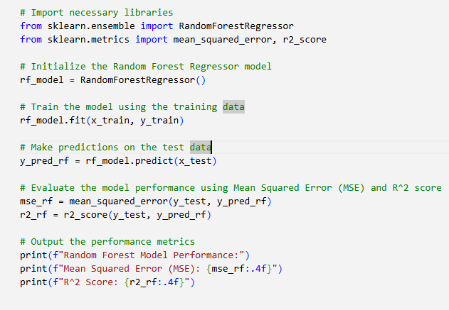
Figure: CODE for Random forest
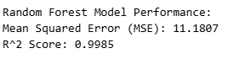
Figure: performance for Random forest

EXTRA TREE REGRESSOR:

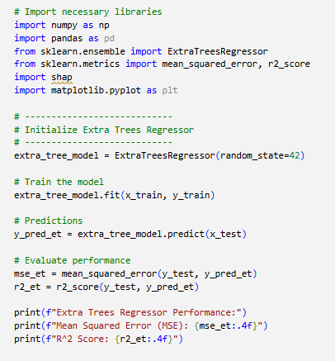
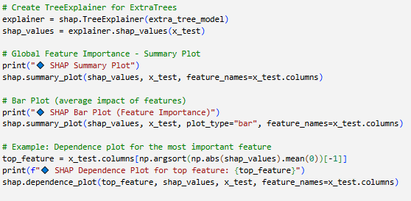
Figure: CODE for Extra Tree Regressor
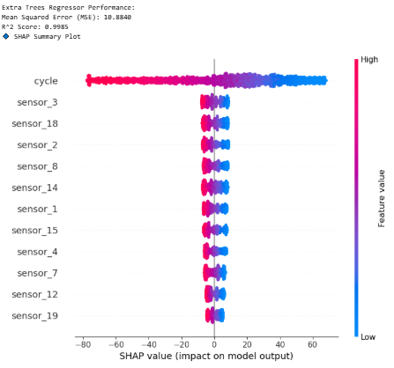
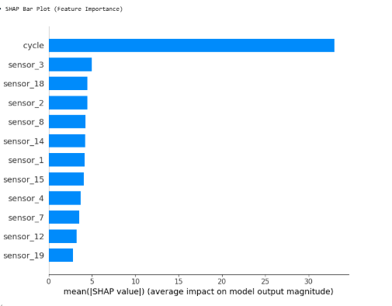

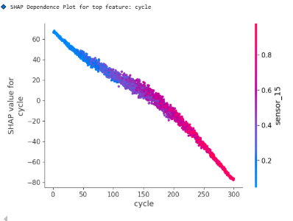
Figure: Explainable AI for Extra Tree Regressor

LIGHT GBM REGRESSOR :
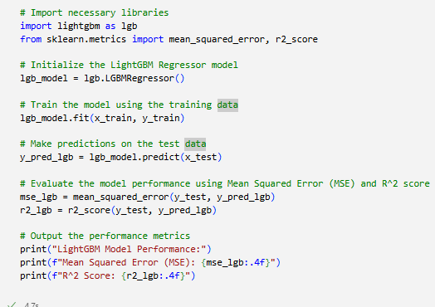
Figure: CODE for LIGHT GBM

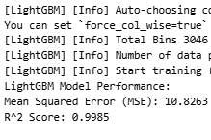
Figure: Performance report of LIGHT GBM

MLP REGRESSOR :
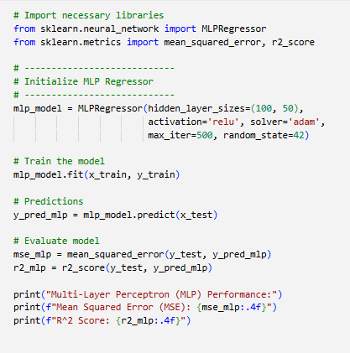
Figure: CODE for MLP
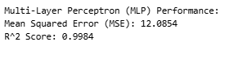
Figure: Performance report of MLP
FNN :
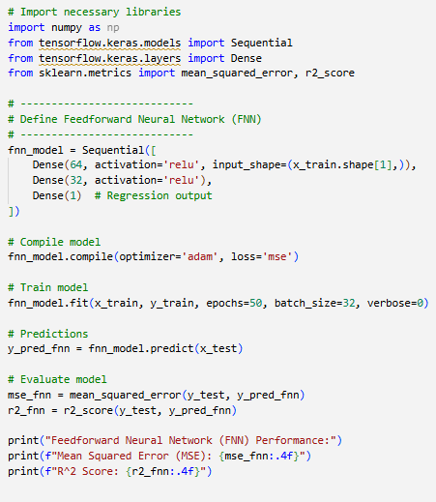
Figure: CODE for FNN
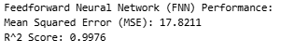
Figure: Performance report of FNN

Performance Analysis and Comparative Evaluation of ML Models
This study evaluates the performance of multiple machine learning models—Random Forest, Logistic Regression, Gradient Boosting, and Decision Tree—applied to a real-time Ambient Assisted Living (AAL) system for elderly healthcare. These models were trained on a dataset containing vital signs (Heart Rate, Blood Pressure, Glucose Levels, SpO₂) and their threshold flags, with the goal of predicting whether the input indicates a normal condition or an emergency. The evaluation focused on standard metrics: accuracy, precision, recall, F1-score, and confusion matrices, as well as explainability via SHAP values.

Model Performance Summary
All four models—Random Forest, Logistic Regression, Gradient Boosting, and Decision Tree—achieved perfect performance metrics:
- Accuracy = 1.0
- Precision = 1.0
- Recall = 1.0
- F1-score = 1.0
- Confusion Matrices showed 100% correct predictions for both class 0 (normal) and class 1 (emergency), with zero false positives or false negatives.
The classification reports across all models were identical:
- Class 0 (Normal): precision = 1.00, recall = 1.00, F1 = 1.00
- Class 1 (Emergency): precision = 1.00, recall = 1.00, F1 = 1.00
- Total support: 4421 instances (2197 normal, 2224 emergency)
This indicates that, on the provided dataset, all models are capable of distinguishing between normal and emergency health states with absolute accuracy. However, while such results may indicate strong model performance, they also raise concerns about overfitting—especially if the data lacks sufficient noise or real-world variability.

Visual Insights from Confusion Matrices
Each model's confusion matrix confirms flawless classification. The visual heatmaps (Figures 2, 5, and 8) reinforce the tabular results with zero off-diagonal values, suggesting no misclassifications. This is particularly notable given the class balance between normal and emergency samples, which makes such high scores statistically significant.

Explainability Analysis
SHAP visualizations provide an important interpretability layer, especially in the Random Forest and Decision Tree outputs. The model identifies features like:
- Blood Pressure
- Glucose Levels
- Heart Rate
- Oxygen Saturation (SpO₂)
For example, in one SHAP explanation (Image 3), the feature "Glucose Levels = 81.00" contributed slightly toward a class 1 prediction, while all other features indicated a class 0 (normal) outcome. However, due to their normal values, the final probability leaned completely toward Class 0, with 100% certainty. This interpretability builds trust, especially for caregivers, as it shows which physiological readings influenced the model’s decision.

Comparative Evaluation
Despite identical metric outcomes, the models differ in architecture and computational traits:
- Random Forest: Offers robustness and interpretability. Excellent for handling noise, but can be computationally expensive in large deployments.
- Logistic Regression: Simplest and fastest. Ideal for baseline comparisons and real-time systems with tight latency requirements.
- Gradient Boosting: Known for accuracy and handling of feature interactions. Slightly slower but excels in edge cases.
- Decision Tree: Highly interpretable and fast, though it can overfit without regularization.
Given their performance parity, model selection can be based on infrastructure, use case (e.g., need for explainability vs. speed), or deployment environment (edge vs. cloud).

10. CONCLUSION:
The project, Prediction of Remaining Useful Life (RUL) for AeroEngines, demonstrates the potential of Machine Learning-driven predictive maintenance in aviation by providing an intelligent framework that accurately estimates the operational lifespan of aircraft engines. By leveraging ensemble methods such as Extra Trees Regressor, Random Forest, Gradient Boosting, XGBoost, and neural networks, the system effectively analyzes multivariate sensor inputs—including temperature, pressure, and vibration—to detect degradation trends and generate reliable RUL predictions. Unlike traditional maintenance strategies that often lead to either unnecessary servicing or catastrophic failures, this data-driven approach ensures proactive, cost-effective, and safety-oriented decision-making. The classification of predictions into critical, warning, and normal categories, coupled with actionable maintenance suggestions, transforms complex outputs into practical insights that support engineers and operators in preventing downtime and optimizing resource allocation. The user-friendly Flask-based web interface, integrated with MySQL for secure authentication and data management, provides an interactive platform where users can register, upload datasets, select models, and obtain predictions seamlessly. Experimental results validate the system’s high accuracy and consistency, highlighting the superior performance of ensemble learning models in predicting aeroengine health states. Furthermore, the modular architecture allows for future scalability, enabling integration with additional machine learning models, real-time streaming sensor data, and cloud-based deployment for large-scale adoption. By bridging the gap between raw sensor data and actionable insights, the framework fosters a shift from reactive to proactive maintenance in aviation, thereby reducing operational costs, improving reliability, and enhancing passenger safety. In conclusion, this project lays a strong foundation for intelligent, explainable, and sustainable predictive maintenance in aerospace, with future scope for expansion into real-time IoT integration, multilingual user interfaces, and advanced visualization techniques to further strengthen its usability and impact in real-world aviation ecosystems.
.

11. FUTURE ENHANCEMENT

Future enhancements for the Remaining Useful Life (RUL) Prediction System for AeroEngines will focus on expanding data diversity, integrating advanced AI techniques, and improving real-world usability to strengthen predictive maintenance capabilities in aviation. Incorporating additional sensor parameters such as exhaust gas temperature, oil pressure, acoustic emissions, and fuel flow rates, along with flight condition metadata like altitude, speed, and weather, will enrich model understanding of degradation patterns and improve generalization across diverse operational contexts. Large-scale, longitudinal datasets collected from multiple fleets and operational environments will further reduce bias and enhance robustness, while synthetic data generation using Generative AI (GenAI) can address rare or extreme failure cases, ensuring preparedness for critical events. Explainable AI (XAI) techniques such as SHAP or LIME will add transparency by highlighting influential sensor features behind predictions, improving user trust and supporting engineers in validation and decision-making. Real-world pilot deployments with airlines and MRO (Maintenance, Repair, and Overhaul) organizations will provide valuable insights into prediction accuracy, alert reliability, and usability under varying sensor quality and connectivity conditions, helping refine system resilience through adaptive error handling and dynamic thresholds. User experience can also be elevated by introducing role-specific dashboards: concise, actionable alerts for technicians, predictive scheduling for fleet managers, and trend-based insights for analysts, with cloud-based and mobile-ready interfaces for accessibility in operational settings.

12. REFERENCES:
- Shen, L., Wang, Y., Du, B., Yang, H., & Fan, H. (2025). Remaining Useful Life Prediction of Aero-Engine Based on Improved GWO and 1DCNN. Machines, 13(7), 583. doi:10.3390/machines13070583 MDPI
- Deng, S., & Zhou, J. (2024). Prediction of Remaining Useful Life of Aero-engines Based on CNN-LSTM-Attention. International Journal of Computational Intelligence Systems, 17, 232. SpringerLink
- Elsherif, S.M., et al. (2025). A deep learning-based prognostic approach for predicting the remaining useful life (RUL) of aero-engines using an Attention-based Gated Recurrent Unit (ABGRU). Scientific Reports. Nature
- Liu, L., Wang, T., & others. (2021). Remaining Useful Life Estimation of Aircraft Engines Based on Deep Convolution Neural Network and LightGBM Combination Model. International Journal of Computational Intelligence Systems. SpringerLink
- Liu, Q., et al. (2024). Enhancing aircraft engine remaining useful life prediction via historical data and advanced model architectures. Journal of Critical Design & Engineering. Oxford Academic
- Sun, S., et al. (2024). Few-shot RUL prediction for engines based on CNN-GRU. PMC (public health / engineering journal). PMC
- Li, D., et al. (2025). Remaining useful life prediction of a small sample of aero-engines: a data-physics fusion framework using the NASA turbine engine public dataset. ScienceDirect. ScienceDirect
- Jafari, S., et al. (2022). XGBoost-based Remaining Useful Life Estimation Model (battery domain, but relevant ensemble / boosting techniques). Sensors, 22(23), 9522. MDPI
- Khan, T., Ahmad, K., Khan, J., Imran, K., & Ahmad, N. (2022). An Explainable Regression Framework for Predicting Remaining Useful Life of Machines. arXiv preprint arXiv:2204.13574. arXiv
- Solis-Martin, D., Galan-Paez, J., & Borrego-Diaz, J. (2021). A stacked deep convolutional neural network to predict the remaining useful life of a turbofan engine. arXiv preprint arXiv:2111.12689. arXiv
- Peringal, A., Basheer Mohiuddin, M., & Hassan, A. (2024). Remaining Useful Life Prediction for Aircraft Engines using LSTM. arXiv preprint arXiv:2401.07590. arXiv

